**Sprint 1 Retrospective**

**Product:** SquadUp

**Team:** The Big Ballers

**Revision date:** 7/9/2018

**Actions to stop doing:**

Stop outside distractions by allocating 1 to 2 hours of quiet study time per day. This will hope overall productivity and create actionable items that are completed.

**Actions to start doing:**

The team communication is a big part of our process. We should utilize more of Slack for notifying team members of actionable items or changes in the current build. Making sure that all commenting/documentation practices are always being followed.

**Actions to keep doing:**

Keeping up to date on our documentation to keep all members up to date on how the software parts coincide with one another. We should keep our scrum meeting times in the afternoon because this accommodates all the members schedules.

**Work completed/not completed:**

The user stories completed are as follows:  
  
1. As a developer, I want to set up our development environment so that we have a basic starting point.

2. As a user, I want to be able to create an account so that I can manage my profile.

The user story that was not completed:

3. As a user, I want to search for parks in my area so that I can find a park to go to.

**Work completion rate:**  
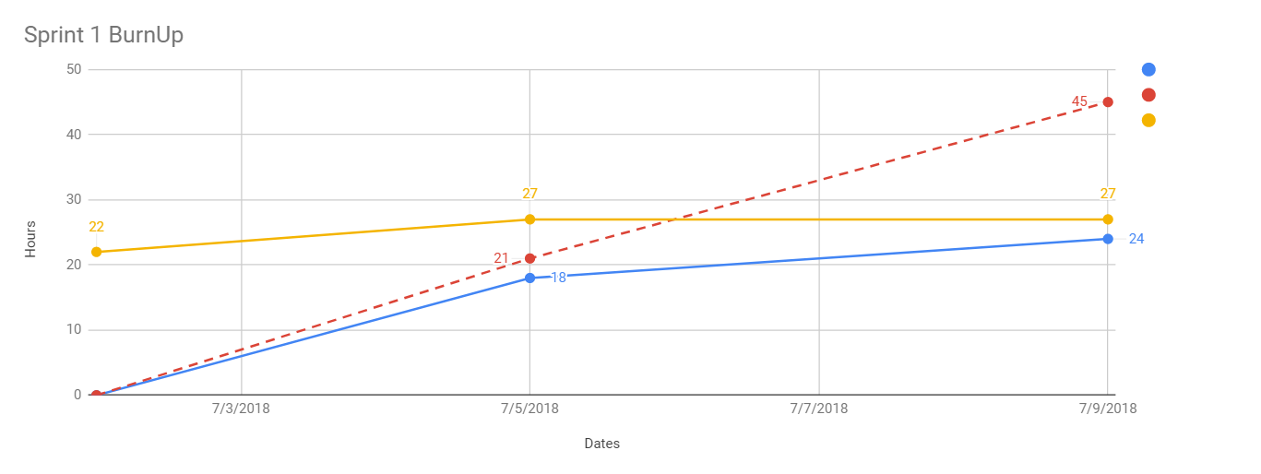

Based on the first sprint, we completed 2 user stories and had one pushed back to the product backlog. The user stories completed are as follows:  
  
1. As a developer, I want to set up our development environment so that we have a basic starting point

2. As a guest, I want to be able to create an account so that I can manage my profile

The user story that was not completed:

3. As a guest, I want to search for parks in my area so that I can find a park to go to.

The burnup chart shown has a key, blue being estimated hours completed, red being the actual hours completed, and yellow being the total estimated hours. Just by looking at the chart it is obvious that we underestimated the hours necessary to complete the tasks for user stories 1 and 2. The amount of actual hours was 45 hours, and the estimated total hours was 27 hours. We are over by 18 working hours. This shows that the underestimate in the tasks might have been caused by learning a completely new technologies. We will have to compensate for this mistake in future sprints.